**Goa Vidya Prasarak Mandal’s**

**G.G.P.R. COLLEGE OF COMMERCE & ECONOMICS**

**FARMAGUDI PONDA GOA**

**MINI PROJECT**

**ATM MANAGEMENT SYSTEM**

**ISA 1**

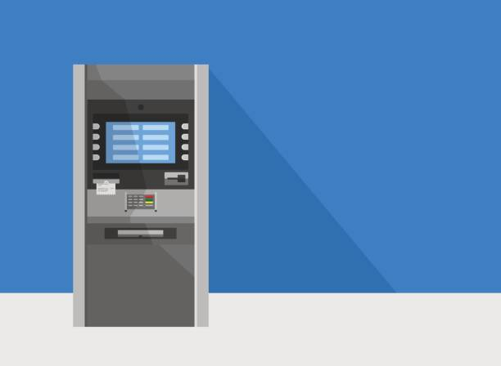

**NAME: ANIMISH SHRIVANT**

**ADMISSION NO.: 192019**

**CLASS: SYBCA**

**TOPIC: ATM MANAGEMENT SYSTEM**

**SUBJECT: UID LABORATORY**

**INTRODUCTION**

* In my project ATM MANAGEMENT SYSTEM, I have tried to explain and focus on how can the users be comfortable in using my UI. The main objective of ATM Management System is to manage all the details i.e., User’s Account no., First name, Last name etc. This system allows to retrieve, delete, register and search for the particular user’s data, which avoids the complexity of human task. This UI helps the user to check balance, deposit some amount or withdraw it. This is a simple application for users who are not techy kind of people. This project gives us the complete information about users account. We can add balance to account and also retrieve the information about user’s account.
* Throughout the project the focus has been on how user’s can be comfortable in using this application. This project is very easy and useful for the end user.

**FEATURES OF THIS SYSTEM**

* LOGIN
* REGISTRATION
* BALANCE
* DEPOSIT
* WITHDRAW
* DELETE

**ADVANTAGES**

* The purpose of the **ATM System** is used to provide quality safety and to provide security through with the monetary and it’s easy to access and to secured for your account.
* This system can help people to make easier and faster their processing withdrawal of their account.
* **WELCOME FORM**

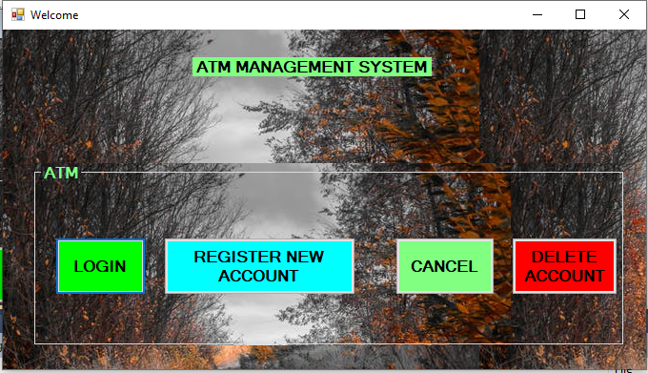

* **WELCOME CODE**

Public Class Welcome

Private Sub Button1_Click(ByVal sender As System.Object, ByVal e As System.EventArgs) Handles Button1.Click

Me.Hide()

Login.Show()

End Sub

Private Sub Button2_Click(ByVal sender As System.Object, ByVal e As System.EventArgs) Handles Button2.Click

End

End Sub

Private Sub Button3_Click(ByVal sender As System.Object, ByVal e As System.EventArgs) Handles Button3.Click

Me.Hide()

Registration.Show()

End Sub

Private Sub Button4_Click(ByVal sender As System.Object, ByVal e As System.EventArgs) Handles Button4.Click

Me.Hide()

Delete.Show()

End Sub

End Class

* **LOGIN FORM**

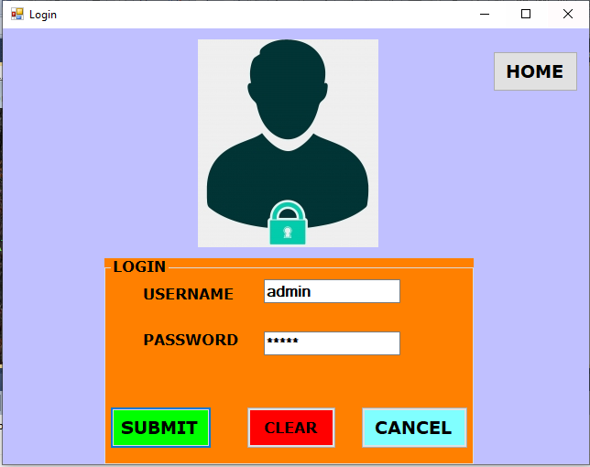

* **LOGIN OUTPUT**

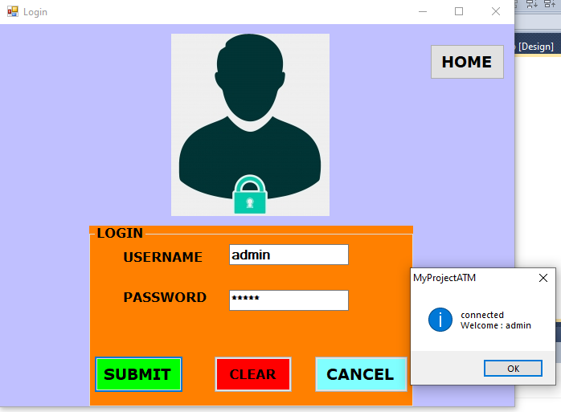

* **LOGIN DATABASE**

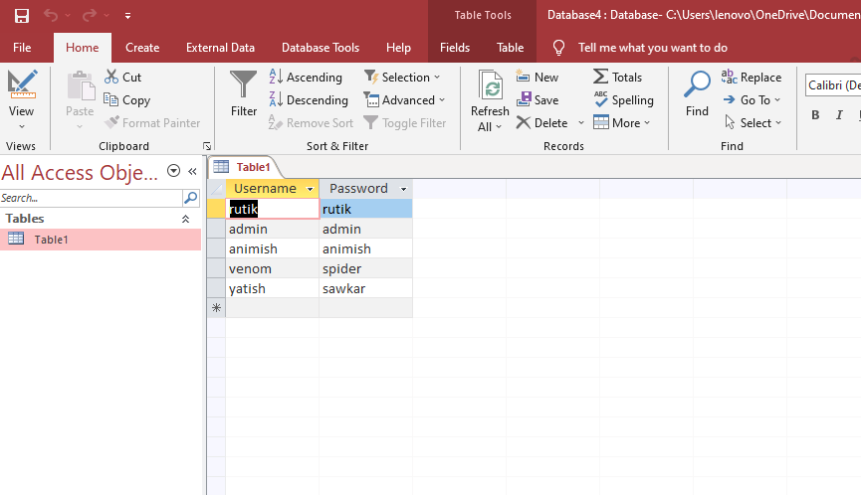

* **LOGIN CODE**

Imports System.Data.OleDb

Imports System.Data

Public Class Login

Private Sub Button2_Click(ByVal sender As System.Object, ByVal e As System.EventArgs) Handles Button2.Click

End

End Sub

Private Sub Button1_Click(ByVal sender As System.Object, ByVal e As System.EventArgs) Handles Button1.Click

Dim connect As New OleDbConnection

Dim cmd As OleDbCommand

Dim qry As String

Dim dr As OleDbDataReader

qry = "SELECT Username,Password FROM Table1 WHERE Username='" + TextBox1.Text + "' and Password='" + TextBox2.Text + "'"

connect.ConnectionString = "Provider=Microsoft.ACE.OLEDB.12.0;Data Source=C:\Users\lenovo\OneDrive\Documents\Database4.accdb"

Try

connect.Open()

cmd = New OleDbCommand(qry, connect)

cmd.ExecuteNonQuery()

dr = cmd.ExecuteReader

If dr.Read Then

MsgBox("connected" & vbNewLine & "Welcome : " & TextBox1.Text, MsgBoxStyle.Information)

connect.Close()

Main.Show()

Me.Visible = False

Else

MsgBox("Username & Password does not match")

End If

Catch ex As Exception

MessageBox.Show(ex.Message)

End Try

End Sub

Private Sub Button3_Click(ByVal sender As System.Object, ByVal e As System.EventArgs) Handles Button3.Click

Me.Hide()

Welcome.Show()

End Sub

Private Sub TextBox2_TextChanged(ByVal sender As System.Object, ByVal e As System.EventArgs) Handles TextBox2.TextChanged

End Sub

Private Sub Button4_Click(ByVal sender As System.Object, ByVal e As System.EventArgs) Handles Button4.Click

TextBox1.Clear()

TextBox2.Clear()

End Sub

End Class

* **REGISTRATION FORM**

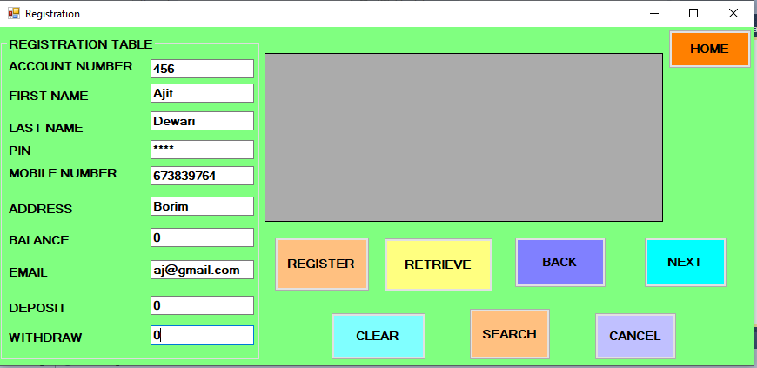

* **REGISTRATION OUTPUT**

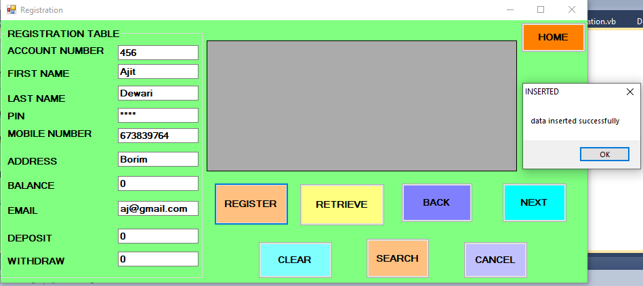

* **AFTER RETRIEVING**

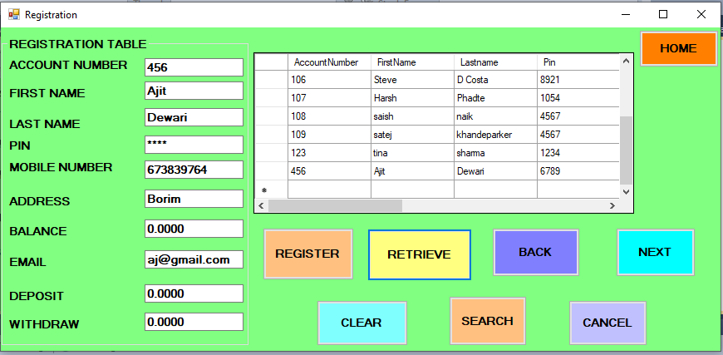

* **REGISTRATION CODE**

Imports System.Data.OleDb

Public Class Registration

Dim pro As String

Dim connstring As String

Dim command As String

Dim ds As New OleDbDataAdapter

Dim conn As New OleDbConnection

Dim dt As New DataTable

Dim myconnection As OleDbConnection = New OleDbConnection

Private Sub Button1_Click(ByVal sender As System.Object, ByVal e As System.EventArgs) Handles Button1.Click

Dim conn As New OleDb.OleDbConnection

Dim connStr As String = "Provider=Microsoft.ACE.OLEDB.12.0;Data Source=C:\Users\lenovo\OneDrive\Documents\Database3.accdb"

Dim cmd As OleDbCommand = New OleDbCommand(command, myconnection)

Dim a As String

conn.ConnectionString = connStr

conn.Open()

cmd.Connection = conn

cmd.CommandText = "INSERT INTO Table1 VALUES(@AccountNumber, @FirstName, @LastName, @Pin, @MobileNumber, @Address, @Balance, @Email, @Deposit, @Withdraw)"

cmd.Parameters.AddWithValue("@AccountNumber", TextBox1.Text)

cmd.Parameters.AddWithValue("@FirstName", TextBox2.Text)

cmd.Parameters.AddWithValue("@LastName", TextBox3.Text)

cmd.Parameters.AddWithValue("@Pin", TextBox4.Text)

cmd.Parameters.AddWithValue("@MobileNumber", TextBox5.Text)

cmd.Parameters.AddWithValue("@Address", TextBox6.Text)

cmd.Parameters.AddWithValue("@Balance", TextBox7.Text)

cmd.Parameters.AddWithValue("@Email", TextBox8.Text)

cmd.Parameters.AddWithValue("@Deposit", TextBox9.Text)

cmd.Parameters.AddWithValue("@Withdraw", TextBox10.Text)

MessageBox.Show("data inserted successfully", "INSERTED", MessageBoxButtons.OK)

Try

cmd.ExecuteNonQuery()

cmd.Dispose()

TextBox1.Clear()

TextBox2.Clear()

TextBox3.Clear()

TextBox4.Clear()

TextBox5.Clear()

TextBox6.Clear()

TextBox7.Clear()

TextBox8.Clear()

TextBox9.Clear()

TextBox10.Clear()

TextBox1.Focus()

Main.Visible = True

Me.Visible = False

conn.Close()

Catch ex As Exception

MessageBox.Show(ex.Message)

End Try

End Sub

Private Sub Button2_Click(ByVal sender As System.Object, ByVal e As System.EventArgs) Handles Button2.Click

Dim conn As New OleDbConnection

Dim ds As New OleDbDataAdapter

Dim dt As New DataTable

conn.ConnectionString = "Provider=Microsoft.ACE.OLEDB.12.0;Data Source=C:\Users\lenovo\OneDrive\Documents\Database3.accdb"

conn.Open()

ds = New OleDbDataAdapter("select * from Table1 ", conn)

ds.Fill(dt)

DataGridView1.DataSource = dt.DefaultView

conn.Close()

End Sub

Private Sub Button3_Click(ByVal sender As System.Object, ByVal e As System.EventArgs) Handles Button3.Click

Welcome.Visible = True

Me.Visible = False

End Sub

Private Sub Button4_Click(ByVal sender As System.Object, ByVal e As System.EventArgs) Handles Button4.Click

Me.Hide()

Welcome.Show()

End Sub

Private Sub Label12_Click(ByVal sender As System.Object, ByVal e As System.EventArgs)

End Sub

Private Sub Button5_Click(ByVal sender As System.Object, ByVal e As System.EventArgs) Handles Button5.Click

Me.Hide()

Main.Show()

End Sub

Private Sub Button6_Click(ByVal sender As System.Object, ByVal e As System.EventArgs) Handles Button6.Click

TextBox1.Clear()

TextBox2.Clear()

TextBox3.Clear()

TextBox4.Clear()

TextBox5.Clear()

TextBox6.Clear()

TextBox7.Clear()

TextBox8.Clear()

TextBox9.Clear()

TextBox10.Clear()

End Sub

Private Sub Button7_Click(ByVal sender As System.Object, ByVal e As System.EventArgs) Handles Button7.Click

Dim conn As New OleDbConnection

conn.ConnectionString = "Provider=Microsoft.ACE.OLEDB.12.0;Data Source=C:\Users\lenovo\OneDrive\Documents\Database3.accdb"

conn.Open()

Dim command As String

command = "select AccountNumber, FirstName, LastName, Pin, MobileNumber, Address, Balance, Email, Deposit, Withdraw from Table1 where AccountNumber=" & TextBox1.Text & ""

Dim cmd As New OleDbCommand(command, conn)

Dim myreader As OleDbDataReader

myreader = cmd.ExecuteReader

myreader.Read()

TextBox1.Text = myreader("AccountNumber")

TextBox2.Text = myreader("FirstName")

TextBox3.Text = myreader("LastName")

TextBox4.Text = myreader("Pin")

TextBox5.Text = myreader("MobileNumber")

TextBox6.Text = myreader("Address")

TextBox7.Text = myreader("Balance")

TextBox8.Text = myreader("Email")

TextBox9.Text = myreader("Deposit")

TextBox10.Text = myreader("Withdraw")

Dim comm As New OleDbDataAdapter

Dim dt As New DataTable

comm = New OleDbDataAdapter("select AccountNumber, FirstName, LastName, Pin, MobileNumber, Address, Balance, Email, Deposit, Withdraw from Table1 where AccountNumber=" & TextBox1.Text & "", conn)

conn.Close()

End Sub

Private Sub Button8_Click(ByVal sender As System.Object, ByVal e As System.EventArgs) Handles Button8.Click

End

End Sub

End Class

* **REGISTRATION DATABASE**

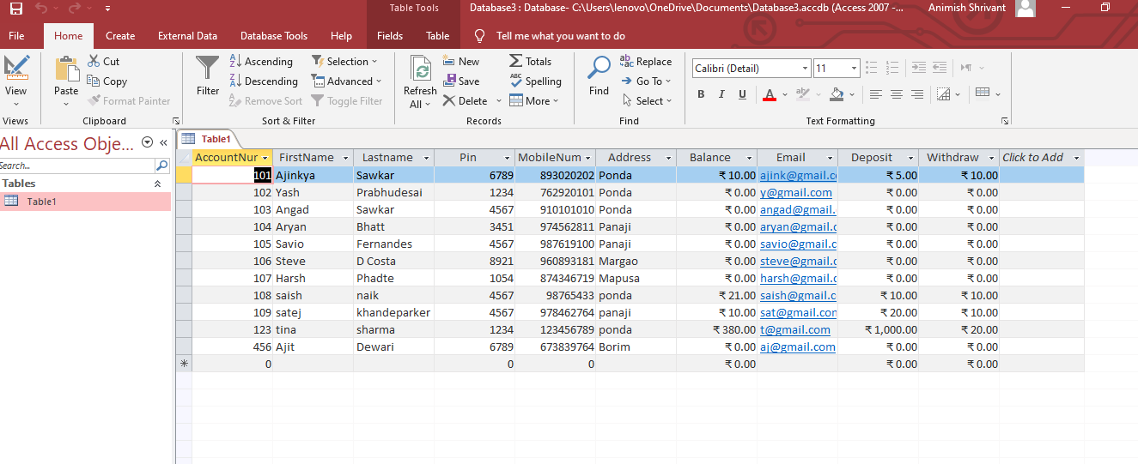

* **MAIN FORM**

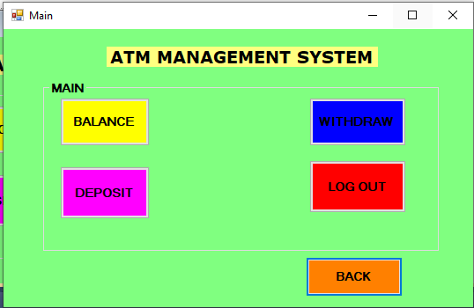

* **MAIN CODE**

Public Class Main

Private Sub Button5_Click(ByVal sender As System.Object, ByVal e As System.EventArgs) Handles Button5.Click

Me.Hide()

Login.Show()

End Sub

Private Sub Button1_Click(ByVal sender As System.Object, ByVal e As System.EventArgs) Handles Button1.Click

Me.Hide()

Balance.Show()

End Sub

Private Sub Button2_Click(ByVal sender As System.Object, ByVal e As System.EventArgs) Handles Button2.Click

Me.Hide()

Withdraw.Show()

End Sub

Private Sub Button3_Click(ByVal sender As System.Object, ByVal e As System.EventArgs) Handles Button3.Click

Me.Hide()

Deposit.Show()

End Sub

Private Sub Button4_Click(ByVal sender As System.Object, ByVal e As System.EventArgs)

End Sub

Private Sub Button6_Click(ByVal sender As System.Object, ByVal e As System.EventArgs) Handles Button6.Click

Me.Hide()

Login.Show()

End Sub

End Class

* **DEPOSIT FORM**

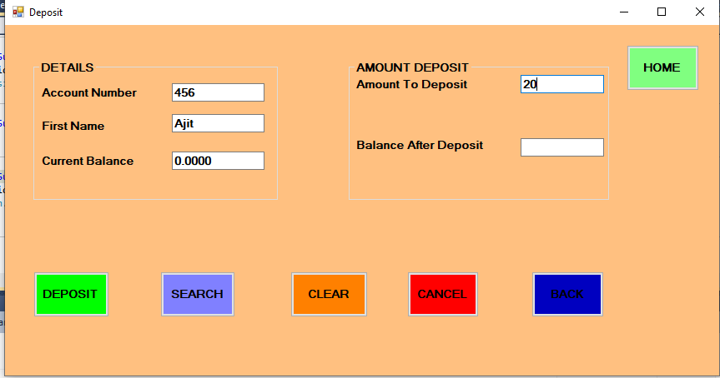

* **DEPOSIT OUTPUT**

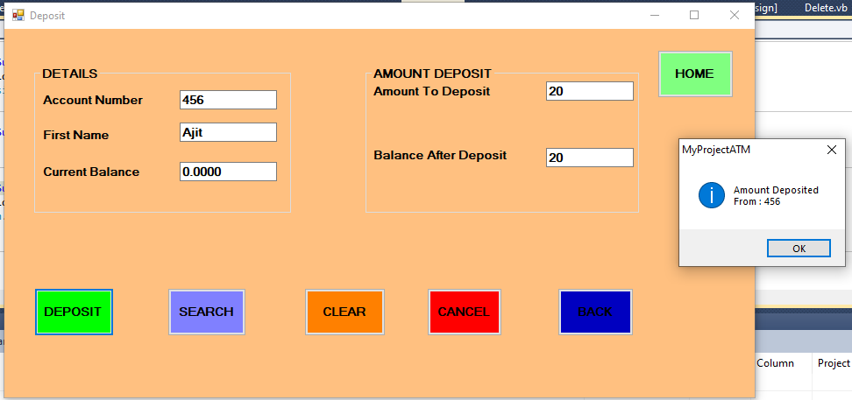

* **IN DATABASE**

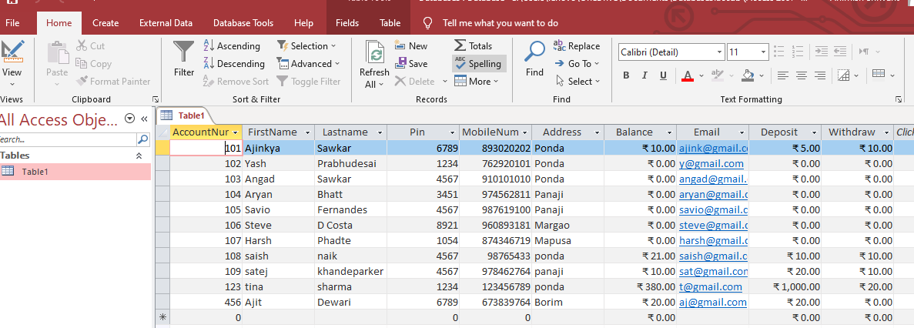

* **DEPOSIT CODE**

Imports System.Data.OleDb

Imports System.Data

Public Class Deposit

Dim n, c As Integer

Private Sub Button1_Click(ByVal sender As System.Object, ByVal e As System.EventArgs) Handles Button1.Click

Dim pro As String

Dim connstring As String

Dim command As String

Dim myconnection As OleDbConnection = New OleDbConnection

pro = "Provider=Microsoft.ACE.OLEDB.12.0;Data Source=C:\Users\lenovo\OneDrive\Documents\Database3.accdb"

connstring = pro

myconnection.ConnectionString = connstring

myconnection.Open()

Dim c As Integer

Dim n As Integer

n = Val(TextBox4.Text)

c = (n + TextBox3.Text)

TextBox5.Text = c

command = "update Table1 set [Deposit]='" & TextBox4.Text & "', [Balance]='" & TextBox5.Text & "' where [AccountNumber]=" & TextBox1.Text & ""

Dim cmd As OleDbCommand = New OleDbCommand(command, myconnection)

MsgBox("Amount Deposited" & vbNewLine & "From : " & TextBox1.Text, MsgBoxStyle.Information)

Try

cmd.ExecuteNonQuery()

cmd.Dispose()

myconnection.Close()

TextBox1.Clear()

TextBox2.Clear()

TextBox3.Clear()

TextBox4.Clear()

TextBox5.Clear()

Catch ex As Exception

MessageBox.Show(ex.Message)

End Try

End Sub

Private Sub Button2_Click(ByVal sender As System.Object, ByVal e As System.EventArgs) Handles Button2.Click

Dim conn As New OleDbConnection

conn.ConnectionString = "Provider=Microsoft.ACE.OLEDB.12.0;Data Source=C:\Users\lenovo\OneDrive\Documents\Database3.accdb"

conn.Open()

Dim command As String

command = "select AccountNumber, FirstName, Balance from Table1 where AccountNumber=" & TextBox1.Text & ""

Dim cmd As New OleDbCommand(command, conn)

Dim myreader As OleDbDataReader

myreader = cmd.ExecuteReader

myreader.Read()

TextBox1.Text = myreader("AccountNumber")

TextBox2.Text = myreader("FirstName")

TextBox3.Text = myreader("Balance")

Dim comm As New OleDbDataAdapter

Dim dt As New DataTable

comm = New OleDbDataAdapter("select AccountNumber, FirstName, Balance from Table1 where AccountNumber=" & TextBox1.Text & "", conn)

conn.Close()

End Sub

Private Sub Button3_Click(ByVal sender As System.Object, ByVal e As System.EventArgs) Handles Button3.Click

End

End Sub

Private Sub Button5_Click(ByVal sender As System.Object, ByVal e As System.EventArgs) Handles Button5.Click

Me.Hide()

Main.Show()

End Sub

Private Sub Button4_Click(ByVal sender As System.Object, ByVal e As System.EventArgs) Handles Button4.Click

Me.Hide()

Welcome.Show()

End Sub

Private Sub Button6_Click(ByVal sender As System.Object, ByVal e As System.EventArgs) Handles Button6.Click

TextBox1.Clear()

TextBox2.Clear()

TextBox3.Clear()

TextBox4.Clear()

TextBox5.Clear()

End Sub

End Class

* **WITHDRAWAL FORM**

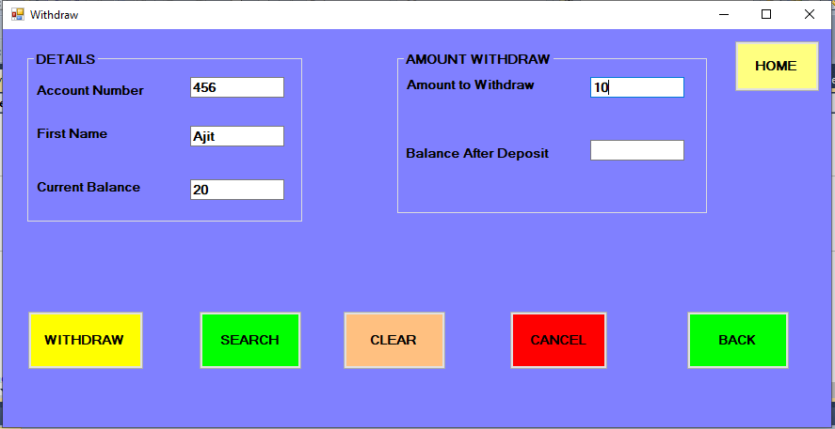

* **WITHDRAWAL OUTPUT**

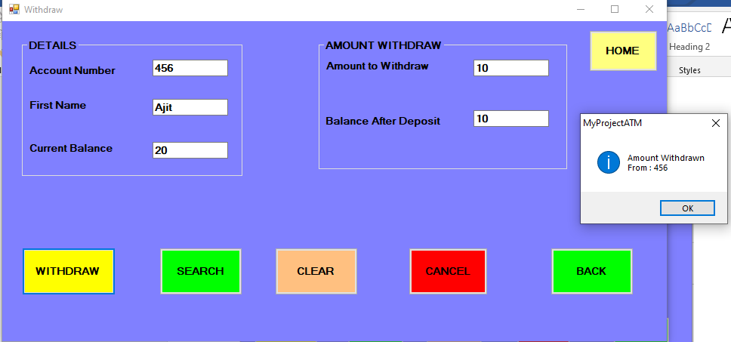

* **IN DATABASE**

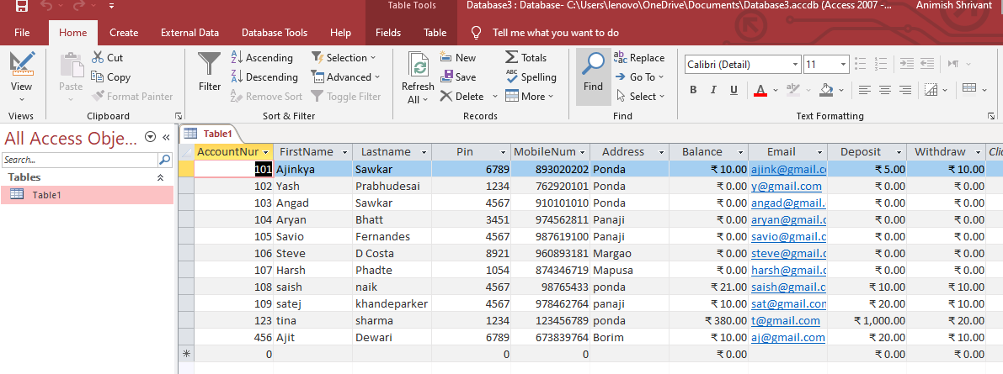

* **WITHDRAWAL CODE**

Imports System.Data.OleDb

Public Class Withdraw

Dim a, b As Integer

Private Sub Button1_Click(ByVal sender As System.Object, ByVal e As System.EventArgs) Handles Button1.Click

Dim pro As String

Dim connstring As String

Dim command As String

Dim myconnection As OleDbConnection = New OleDbConnection

pro = "Provider=Microsoft.ACE.OLEDB.12.0;Data Source=C:\Users\lenovo\OneDrive\Documents\Database3.accdb"

connstring = pro

myconnection.ConnectionString = connstring

myconnection.Open()

b = Val(TextBox4.Text)

a = (TextBox3.Text - b)

TextBox5.Text = a

command = "update Table1 set [Withdraw]='" & TextBox4.Text & "', [Balance]='" & TextBox5.Text & "'where [AccountNumber]=" & TextBox1.Text & ""

Dim cmd As OleDbCommand = New OleDbCommand(command, myconnection)

MsgBox("Amount Withdrawn" & vbNewLine & "From : " & TextBox1.Text, MsgBoxStyle.Information)

Try

cmd.ExecuteNonQuery()

cmd.Dispose()

myconnection.Close()

TextBox1.Clear()

TextBox2.Clear()

TextBox3.Clear()

TextBox4.Clear()

TextBox5.Clear()

Catch ex As Exception

MessageBox.Show(ex.Message)

End Try

End Sub

Private Sub GroupBox1_Enter(ByVal sender As System.Object, ByVal e As System.EventArgs) Handles GroupBox1.Enter

End Sub

Private Sub Withdraw_Load(ByVal sender As System.Object, ByVal e As System.EventArgs) Handles MyBase.Load

End Sub

Private Sub Button5_Click(ByVal sender As System.Object, ByVal e As System.EventArgs)

End Sub

Private Sub Button2_Click(ByVal sender As System.Object, ByVal e As System.EventArgs)

End Sub

Private Sub Button2_Click_1(ByVal sender As System.Object, ByVal e As System.EventArgs) Handles Button2.Click

End

End Sub

Private Sub Button3_Click(ByVal sender As System.Object, ByVal e As System.EventArgs) Handles Button3.Click

Me.Hide()

Main.Show()

End Sub

Private Sub Button4_Click(ByVal sender As System.Object, ByVal e As System.EventArgs) Handles Button4.Click

Me.Hide()

Welcome.Show()

End Sub

Private Sub Button5_Click_1(ByVal sender As System.Object, ByVal e As System.EventArgs) Handles Button5.Click

Dim conn As New OleDbConnection

conn.ConnectionString = "Provider=Microsoft.ACE.OLEDB.12.0;Data Source=C:\Users\lenovo\OneDrive\Documents\Database3.accdb"

conn.Open()

Dim command As String

command = "select AccountNumber, FirstName, Balance from Table1 where AccountNumber=" & TextBox1.Text & ""

Dim cmd As New OleDbCommand(command, conn)

Dim myreader As OleDbDataReader

myreader = cmd.ExecuteReader

myreader.Read()

TextBox1.Text = myreader("AccountNumber")

TextBox2.Text = myreader("FirstName")

TextBox3.Text = myreader("Balance")

Dim comm As New OleDbDataAdapter

Dim dt As New DataTable

comm = New OleDbDataAdapter("select AccountNumber, FirstName, Balance from Table1 where AccountNumber=" & TextBox1.Text & "", conn)

conn.Close()

End Sub

Private Sub Button6_Click(ByVal sender As System.Object, ByVal e As System.EventArgs) Handles Button6.Click

TextBox1.Clear()

TextBox2.Clear()

TextBox3.Clear()

TextBox4.Clear()

TextBox5.Clear()

End Sub

End Class

* **BALANCE FORM**

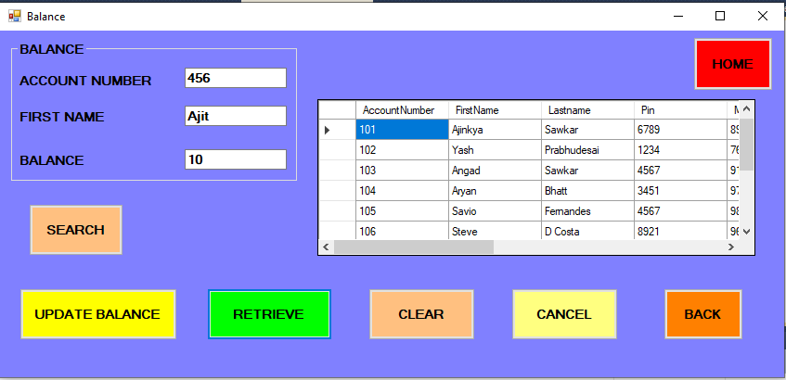

* **BALANCE OUTPUT**

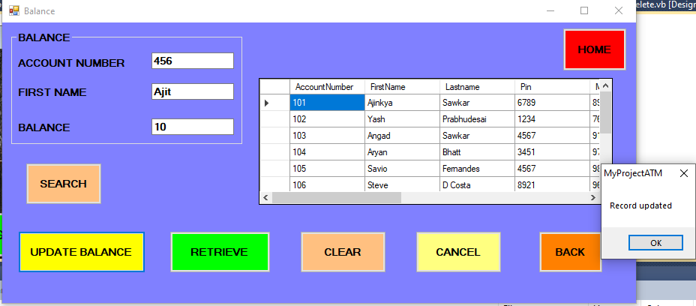

* **IN DATABASE**

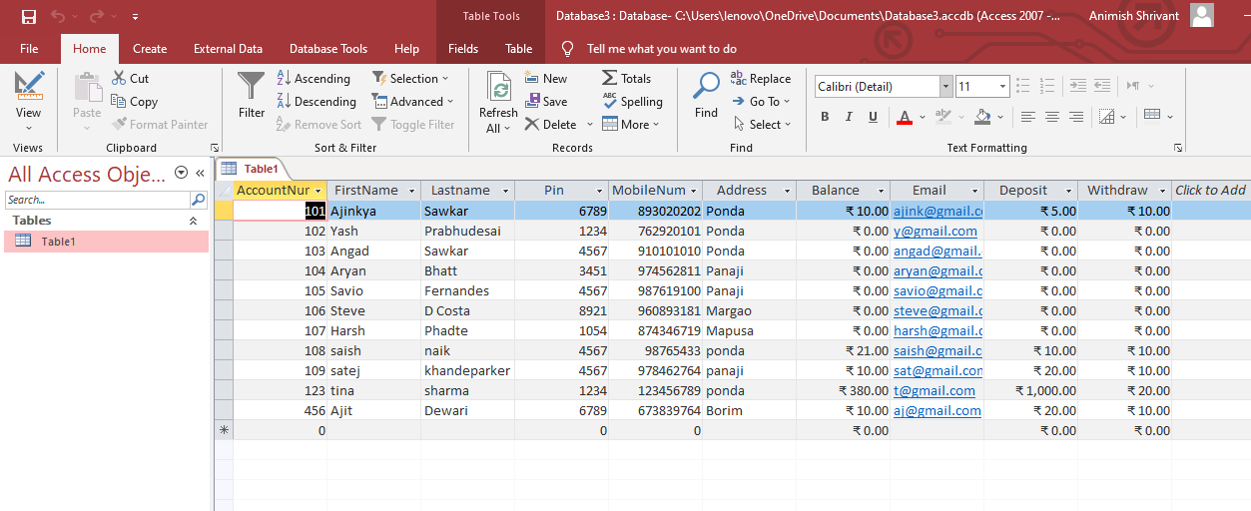

* **BALANCE CODE**

Imports System.Data.OleDb

Imports System.Data

Public Class Balance

Dim pro As String

Dim connstring As String

Dim Command As String

Dim myconnection As OleDbConnection = New OleDbConnection

Private Sub Button1_Click(ByVal sender As System.Object, ByVal e As System.EventArgs) Handles Button1.Click

Dim conn As New OleDbConnection

Dim ds As New OleDbDataAdapter

Dim dt As New DataTable

conn.ConnectionString = "Provider=Microsoft.ACE.OLEDB.12.0;Data Source=C:\Users\lenovo\OneDrive\Documents\Database3.accdb"

conn.Open()

ds = New OleDbDataAdapter("select * from Table1 ", conn)

ds.Fill(dt)

DataGridView1.DataSource = dt.DefaultView

conn.Close()

End Sub

Private Sub Button3_Click(ByVal sender As System.Object, ByVal e As System.EventArgs) Handles Button3.Click

pro = "Provider=Microsoft.ACE.OLEDB.12.0;Data Source=C:\Users\lenovo\OneDrive\Documents\Database3.accdb"

connstring = pro

myconnection.ConnectionString = connstring

myconnection.Open()

Command = "update Table1 set [Balance]='" & TextBox3.Text & "', [FirstName]='" & TextBox2.Text & "' where [AccountNumber]=" & TextBox1.Text & ""

Dim cmd As OleDbCommand = New OleDbCommand(Command, myconnection)

MsgBox("Record updated")

Try

cmd.ExecuteNonQuery()

cmd.Dispose()

myconnection.Close()

TextBox1.Clear()

TextBox2.Clear()

TextBox3.Clear()

Catch ex As Exception

MessageBox.Show(ex.Message)

End Try

End Sub

Private Sub Button2_Click(ByVal sender As System.Object, ByVal e As System.EventArgs) Handles Button2.Click

End

End Sub

Private Sub Button4_Click(ByVal sender As System.Object, ByVal e As System.EventArgs) Handles Button4.Click

Me.Hide()

Welcome.Show()

End Sub

Private Sub Button5_Click(ByVal sender As System.Object, ByVal e As System.EventArgs) Handles Button5.Click

Me.Hide()

Main.Show()

End Sub

Private Sub Button6_Click(ByVal sender As System.Object, ByVal e As System.EventArgs) Handles Button6.Click

Dim conn As New OleDbConnection

conn.ConnectionString = "Provider=Microsoft.ACE.OLEDB.12.0;Data Source=C:\Users\lenovo\OneDrive\Documents\Database3.accdb"

conn.Open()

Dim command As String

command = "select AccountNumber, FirstName, Balance from Table1 where AccountNumber=" & TextBox1.Text & ""

Dim cmd As New OleDbCommand(command, conn)

Dim myreader As OleDbDataReader

myreader = cmd.ExecuteReader

myreader.Read()

TextBox1.Text = myreader("AccountNumber")

TextBox2.Text = myreader("FirstName")

TextBox3.Text = myreader("Balance")

Dim comm As New OleDbDataAdapter

Dim dt As New DataTable

comm = New OleDbDataAdapter("select AccountNumber, FirstName, Balance from Table1 where AccountNumber=" & TextBox1.Text & "", conn)

conn.Close()

End Sub

Private Sub Button7_Click(ByVal sender As System.Object, ByVal e As System.EventArgs) Handles Button7.Click

TextBox1.Clear()

TextBox2.Clear()

TextBox3.Clear()

End Sub

End Class

* **DELETE FORM**

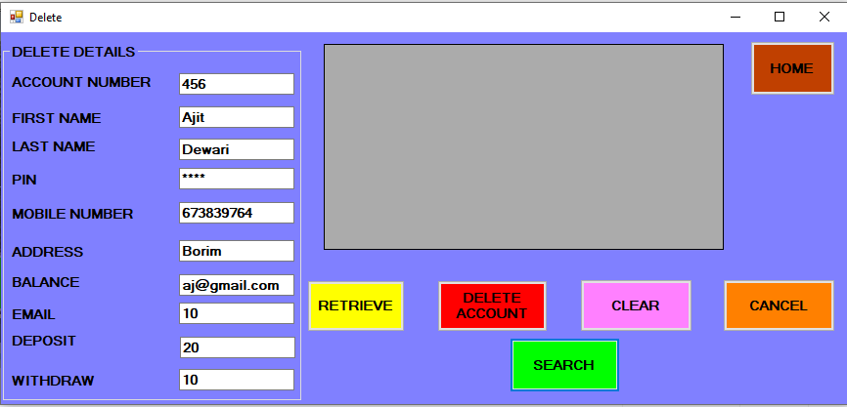

* **DELETE OUTPUT**

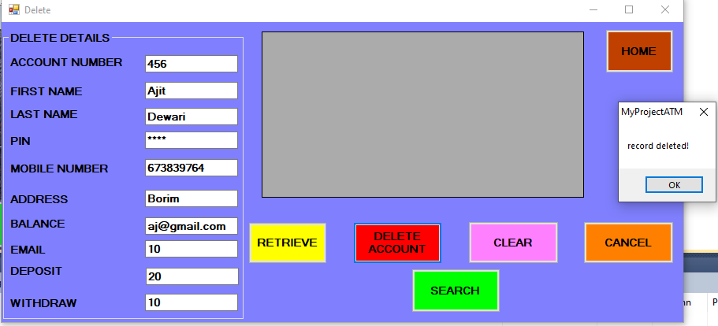

* **AFTER RETRIEVING**

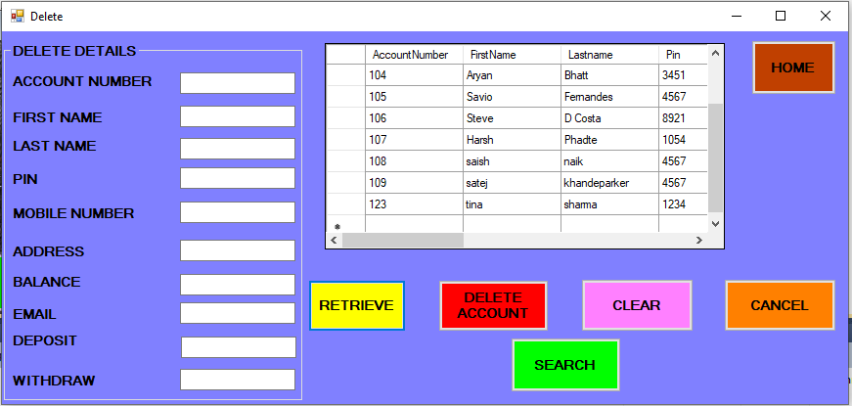

* **IN DATABASE**

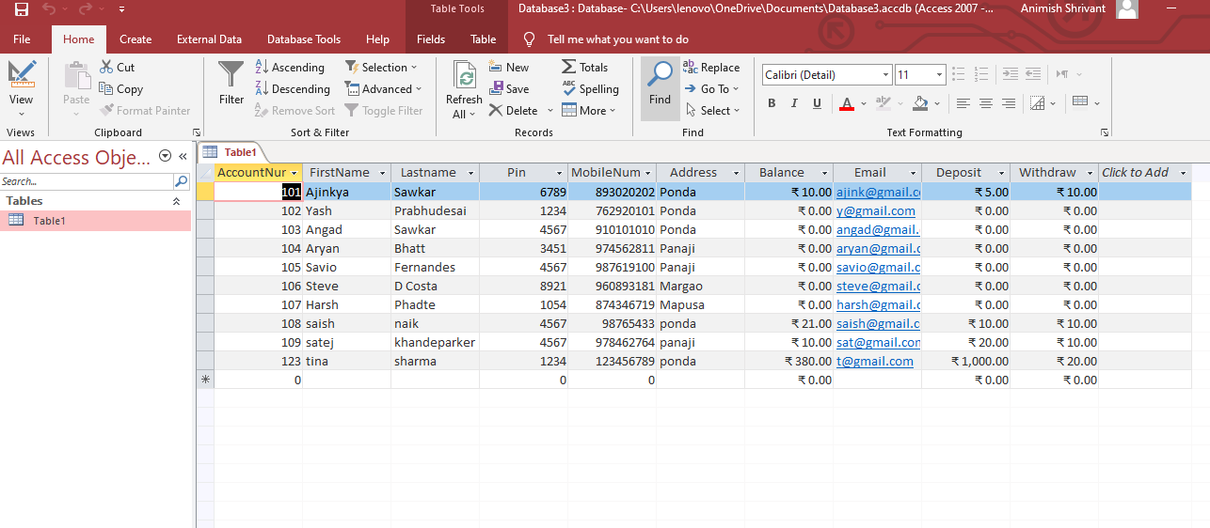

* **DELETE CODE**

Imports System.Data.OleDb

Public Class Delete

Dim pro As String

Dim Command As String

Dim connstring As String

Dim myconnection As OleDbConnection = New OleDbConnection

Private Sub Label4_Click(ByVal sender As System.Object, ByVal e As System.EventArgs) Handles Label4.Click

End Sub

Private Sub TextBox8_TextChanged(ByVal sender As System.Object, ByVal e As System.EventArgs) Handles TextBox8.TextChanged

End Sub

Private Sub Button1_Click(ByVal sender As System.Object, ByVal e As System.EventArgs) Handles Button1.Click

Dim conn As New OleDbConnection

Dim ds As New OleDbDataAdapter

Dim dt As New DataTable

conn.ConnectionString = "Provider=Microsoft.ACE.OLEDB.12.0;Data Source=C:\Users\lenovo\OneDrive\Documents\Database3.accdb"

conn.Open()

ds = New OleDbDataAdapter("select * from Table1 ", conn)

ds.Fill(dt)

DataGridView1.DataSource = dt.DefaultView

conn.Close()

End Sub

Private Sub Button2_Click(ByVal sender As System.Object, ByVal e As System.EventArgs) Handles Button2.Click

Dim pro As String

Dim connstring As String

Dim myconnection As OleDbConnection = New OleDbConnection

Dim Command As String

pro = "Provider=Microsoft.ACE.OLEDB.12.0;Data Source=C:\Users\lenovo\OneDrive\Documents\Database3.accdb"

connstring = pro

myconnection.ConnectionString = connstring

myconnection.Open()

Command = "delete from [Table1] where [AccountNumber] =" & TextBox1.Text & ""

Dim cmd As OleDbCommand = New OleDbCommand(Command, myconnection)

MsgBox("record deleted!")

Try

cmd.ExecuteNonQuery()

cmd.Dispose()

myconnection.Close()

TextBox1.Clear()

TextBox2.Clear()

TextBox3.Clear()

TextBox4.Clear()

TextBox5.Clear()

TextBox6.Clear()

TextBox7.Clear()

TextBox8.Clear()

TextBox9.Clear()

TextBox10.Clear()

TextBox1.Focus()

Welcome.Visible = True

Me.Visible = False

Catch ex As Exception

MsgBox(ex.Message)

End Try

End Sub

Private Sub Button3_Click(ByVal sender As System.Object, ByVal e As System.EventArgs) Handles Button3.Click

End

End Sub

Private Sub Button4_Click(ByVal sender As System.Object, ByVal e As System.EventArgs) Handles Button4.Click

Me.Hide()

Welcome.Show()

End Sub

Private Sub Button5_Click(ByVal sender As System.Object, ByVal e As System.EventArgs) Handles Button5.Click

Dim conn As New OleDbConnection

conn.ConnectionString = "Provider=Microsoft.ACE.OLEDB.12.0;Data Source=C:\Users\lenovo\OneDrive\Documents\Database3.accdb"

conn.Open()

Dim command As String

command = "select AccountNumber, FirstName, LastName, Pin, MobileNumber, Address, Balance, Email, Deposit, Withdraw from Table1 where AccountNumber=" & TextBox1.Text & ""

Dim cmd As New OleDbCommand(command, conn)

Dim myreader As OleDbDataReader

myreader = cmd.ExecuteReader

myreader.Read()

TextBox1.Text = myreader("AccountNumber")

TextBox2.Text = myreader("FirstName")

TextBox3.Text = myreader("LastName")

TextBox4.Text = myreader("Pin")

TextBox5.Text = myreader("MobileNumber")

TextBox6.Text = myreader("Address")

TextBox7.Text = myreader("Balance")

TextBox8.Text = myreader("Email")

TextBox9.Text = myreader("Deposit")

TextBox10.Text = myreader("Withdraw")

Dim comm As New OleDbDataAdapter

Dim dt As New DataTable

comm = New OleDbDataAdapter("select AccountNumber, FirstName, LastName, Pin, MobileNumber, Address, Balance, Email, Deposit, Withdraw from Table1 where AccountNumber=" & TextBox1.Text & "", conn)

conn.Close()

End Sub

Private Sub Button7_Click_1(ByVal sender As System.Object, ByVal e As System.EventArgs) Handles Button7.Click

TextBox1.Clear()

TextBox2.Clear()

TextBox3.Clear()

TextBox4.Clear()

TextBox5.Clear()

TextBox6.Clear()

TextBox7.Clear()

TextBox8.Clear()

TextBox9.Clear()

TextBox10.Clear()

End Sub

Private Sub Button6_Click(ByVal sender As System.Object, ByVal e As System.EventArgs)

End Sub

End Class

**CONCLUSION**

* In this project, my purpose is to only study or having an idea of how ATM management is done. This web application will help you understand the design basics of banking operations and transactions such as checking balance, depositing and withdrawing the amount etc.